Triggering sound effects

Spriter allows you to trigger up to four simultaneous sound effects per frame of any animation you've created. These sounds must first all be placed in a folder called “sounds” in your project folder.

Each sound is played in either of 4 sound channels, so triggering a new sound on the same channel in later frames before the first sound has finished playing will cause the first sound to stop playing and the new sound to take its place.

IMPORTANT: Sounds are assigned to frames in the “ANIMATIONS FRAMES” list in the “Characters and Animations ” window.

To assign a sound to a frame to a frame in your currently selected animation:
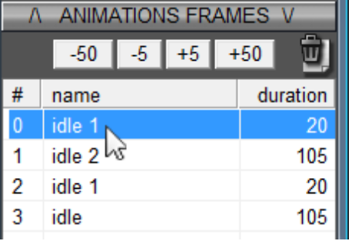
- ) Click on the frame that you would like the sound to be played on in the “ANIMATIONS FRAMES” list in the “Characters and Animations ”window.

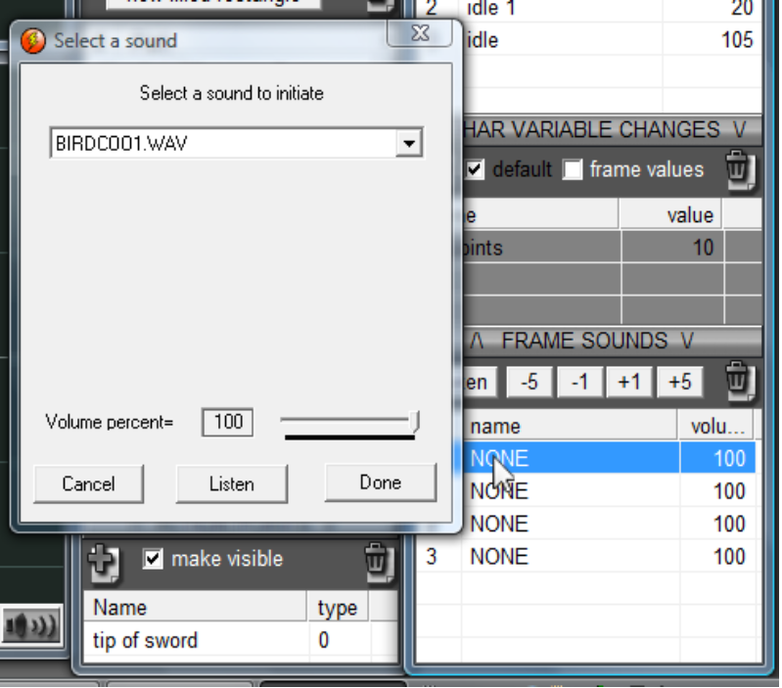
- ) Double click on one of the “sound slots” in the “FRAME SOUNDS” list in the “Characters and Animations ” window.
- ) Use the dialogue that will appear to select one of the sounds. You can also use the dialogues features to tweak the volume that the sound will be played in and to preview the sound at that current volume setting.

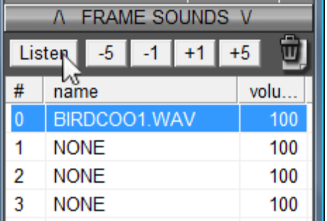
- 4) If you're triggering more than one sound per frame you'll want to be able to listen to all the triggered sounds simultaneously so that you can perfect their respective volume levels. You can do this by holding the “SHIFT” key while clicking on the “Listen” button just above the “FRAME SOUNDS” list.

- 5) For further tweaking of sound volume you can use the “-5”, “-1”, “+1”, and “+5” buttons just to right of the “Listen” button. These buttons will effect any of the sounds you have selected in the “FRAME SOUNDS” list.

